Kernel :- the core of our operating system.

Shell :- the user interface for interacting with the kernel and hardware of your computer.

* 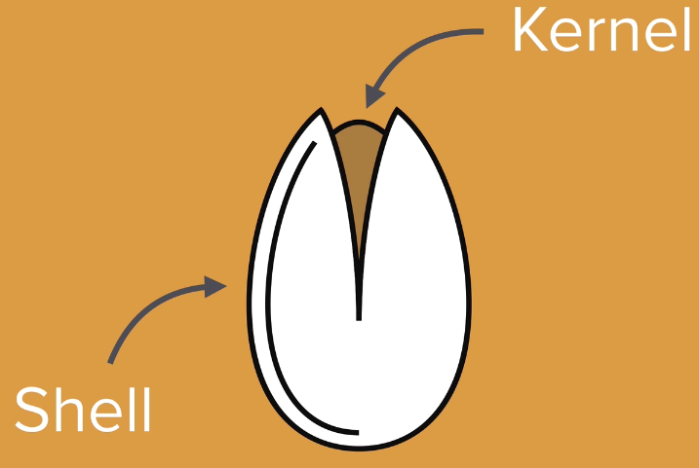

Bash = Bourne Again Shell

* a CLI for the UNIX system

Why use the command line?

* It is much more powerful and grants greater control

mkdir:- used to create a folder or a directory

-mkdir hale

Ls -a :- lists all the files in the directory

mkdir .hale:- creates a secret/hidden file named hale

* We just need to put . before the name of the directory we want to create

cd ~ :- takes you back to your root directory

cd Documents/Bandicam :- takes you to the Bandicam directory

Touching the up button on the keyboard brings the previous commands you have entered and you won’t need to retype them if you want to use them

Alt + cursor: - for clicking on different parts of your command text when you want to use the mouse cursor to edit what you wrote

Ctrl + A: - moves you to the beginning of your command line

Ctrl + E: - moves you to the end of your command line

Ctrl +U :- clear your entire command line for you

Ctrl +C: get out of trouble or stop terminal execution

touch :-used to create a new file inside the directory you are in.

-touch hale.txt :- creates the hale.txt file in your directory

start :- used to open the fle

-start hale.txt :- will open the text file in the default text editor most probably notepad

start atom newfile.txt

-will open the file in atom.

-we can specify the program we want to use for opening the file.

rm newfile.txt

-will delete the file newfile.txt

rm \*

-every file inside that directory will be deleted

rm -r hale

-removes the hale directory/folder together with the files and folders it contains inside of it.

rm -rf hale

-means forced removal. It will never ask you for a confirmation

Serverfault.com

-stackoverlow like website for network/server problems

<https://www.learnenough.com/command-line-tutorial>

-website for learning command line commands